Civil war in Liberia

UNSC Resolution: | 1478
Date of adoption: | 6-May-2003
Operative paragraph: | 9
Demand number: | 1478,0911

Sarah-Myriam Martin-Brûlé

Wording of demand

cease military support for armed groups in neighbouring countries, take action to prevent armed individuals and groups from using their territory to prepare and commit attacks on neighbouring countries and refrain from any actions that might contribute to further destabilization of the situation in the region

List of addressees of the demand

Government of Liberia

Short-term compliance

Description of the addressee(s)’ conduct

“40. During meetings with the Panel, the Government of Guinea has consistently refuted any allegations about its support to LURD. However, on page 4 of its 8 September 2003 issue, the Observateur, a weekly Guinean newspaper, states in an article entitled “The United Nations Representative in Liberia meets the Prime Minister of Guinea” that, “according to diplomatic sources in Conakry, where Sekou Conneh, its leader, lives, the LURD is supported and armed by the Guinean Government with the purpose of destabilizing the Monrovia regime. The authorities in Conakry formerly denied this, even before they were to acknowledge, recently, the effective presence of the central core of this group, through the Minister ofForeign Affairs of Guinea, Lounceny Fall”. The Panel is not aware that any statement officially denying the article has been issued
(…)
42. This is of particular concern because political leaders of the Forces nouvelles acknowledged to the Panel that they had asked for and received support from Charles Taylor and that the President of Côte d’Ivoire, Laurent Gbagbo, had provided arms and logistical support from the armed forces of Côte d’Ivoire (FANCI) to Liberian rebel fighters.
43. Persistent media reports in Abidjan concerning Comstar telecommunications, financial misconduct and money-laundering by high-level Liberian and Ivorian politicians, and funding of LURD and MODEL have undermined the public’s confidence in the Government of Côte d’Ivoire and the judiciary. This scandal is just one example of the destabilizing effects of the Liberian conflict throughout the
region.
44. The Panel obtained information to the effect that an alleged representative of the Government of Côte d’Ivoire named Richard Tho was in charge of the coordination of the Lima rebel forces. Tho is said to have a business card with the seal of the Presidency of Côte d’Ivoire, and is allegedly responsible for making salary payments to the Lima forces. Information has been obtained that the Lima forces now number 1,000 and control the western part of Côte d’Ivoire.
45. Racketeering by police forces continues in Côte d’Ivoire. At least 24 taxi
drivers have been killed in Abidjan over the past two years after refusing to pay
bribes. A Panel member witnessed the police demanding bribes from taxi drivers.
46. Although the United Kingdom and UNAMSIL have focused their support on
building security capabilities of the Government of Sierra Leone in order to prevent
a repetition of the RUF insurgency, fears regarding the ability of the Republic of
Sierra Leone Army to maintain territorial integrity have proved durable. However,
the exile of Charles Taylor is likely to assuage these concerns, particularly after the
expiration of the mandate of UNAMSIL in March 2003. Nevertheless security
concerns remain, in particular in the eastern border town of Koindu in Kailahun
District, where residents and researchers have observed a strong influence of
elements of the former RUF.
Report of the Panel of Experts appointed pursuant to paragraph 25 of Security Council resolution 1478 (2003) concerning Liberia
http://www.reliefweb.int/rw/RWFiles2003.nsf/FilesByRWDocUNIDFileName/ACOS-64BNKH-unsc-lib-28oct.pdf/$File/unsc-lib-28oct.pdf

Assessment

Short-term compliance
X No or marginal compliance (1) | Medium low compliance (2) | Medium high compliance (3) | Full or almost full compliance (4)

Considerations underlying the assessment

Medium-term compliance

Description of the addressee(s)’ conduct

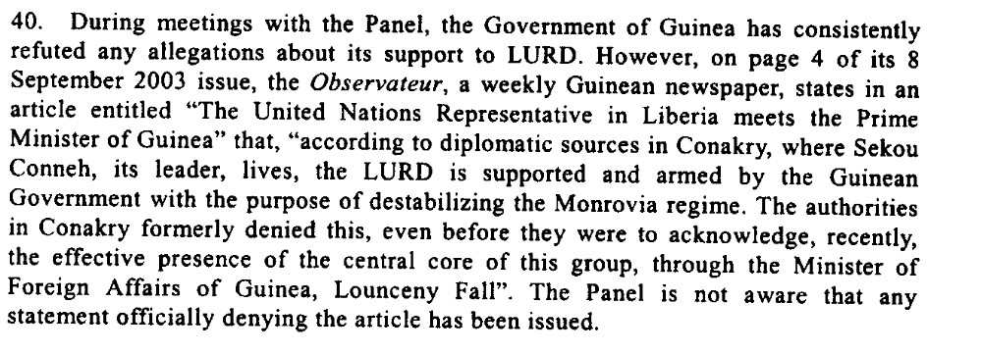
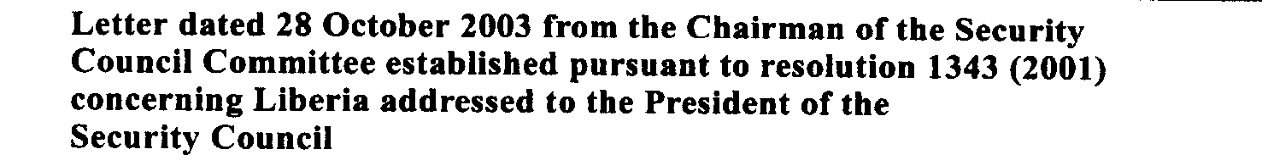

Ivorian President Laurent Gbagbo in turn was sponsoring Liberian forces backing Ivorian loyalists. Recruited mainly from refugees, they formed a militia called Lima, while others crossed back into Liberia to form The Movement for Democracy in Liberia (Model).
Model is made up largely of former fighters from the ULIMO-J militia loyal
to ethnic Krahn leader Roosevelt Johnson who were driven out of Monrovia
in September 1998. After a string of successes, Model was reining in its
military activities by mid-2003, settling into illegal, and profitable, logging.
http://pdfserve.informaworld.com/868637_770885140_714044159.pdf

The deteriorating situation in Côte d'Ivoire may also act as a magnet for regional fighters. Recruitment in Liberia to fight in Côte d'Ivoire is said to be ongoing.114
ICG. 2004. “ Liberia and Sierra Leone: Rebuilding Failed States”. 8 December. Crisis Group Africa Report No. 87.
http://www.crisisgroup.org/library/documents/africa/west_africa/087_liberia_and_sierra_leone_rebuilding_failed_states.pdf

113 Crisis Group interviews with ex-combatant and human rights expert, Monrovia, 16 September 2004, Dakar, 21 August 2004. See also "Taylor loyalist denies recruiting
fighters to destabilise Guinea", IRIN, 29 September 2004. Indications are that Aisha Conneh is recruiting a pro-Conté group, while those opposed to the present government
appear to be aligned primarily with ex-Taylor associates.
ICG. 2004. “ Liberia and Sierra Leone: Rebuilding Failed States”. 8 December. Crisis Group Africa Report No. 87.
http://www.crisisgroup.org/library/documents/africa/west_africa/087_liberia_and_sierra_leone_rebuilding_failed_states.pdf

“10. Reports indicate that, following the completion of disarmament in Sierra Leone, former fighters of RUF and the Civil Defence Forces were recruited to fight in Liberia on behalf of the forces of the Government of Liberia or LURD. Among these “soldiers for hire”, was a group of ex-RUF fighters led by Sam Bockarie and maintained by Charles Taylor. Since the death of Sam Bockarie and the disintegration of the Charles Taylor Government, the situation of those combatants has changed considerably. As it stands, any remaining RUF elements that fought alongside Taylor’s forces would probably be disarmed, demobilized and repatriated to Sierra Leone under the disarmament, demobilization, rehabilitation and reintegration programme provided for in the Comprehensive Peace Agreement and referred to in paragraph 5 above. The Government of Sierra Leone and the National Transitional Government of Liberia are being encouraged to coordinate their actions closely in order to ensure that the ex-combatants are repatriated, resettled and reintegrated into their respective communities. As members of the Council are aware, preparations are currently under way to resume the disarmament, demobilization, rehabilitation and reintegration programme in Liberia. The programme was initially launched in December 2003, but was suspended after it encountered difficulties. In the meantime, consultations are ongoing between the Governments of Sierra Leone and Liberia to determine the most effective way of dealing with foreign combatants located in their territories”
United Nations Security Council. Report of the Secretary-General pursuant to Security Council resolution 1478 (2003) regarding Liberia, S/2004/272, 1 April 2004

“Since April 2004, well over two-thirds of the Liberian ex-combatants interviewed, in addition to several of the Sierra Leoneans, had been asked to join fighting “missions” in Guinea and Côte d’Ivoire. Among those approached to fight in Guinea about half had been approached by commanders claiming to represent a fledgling Guinean insurgency, and the other half by those claiming to be supporters of Guinean President Lansana Conté. Aid organizations and United Nations officials working in Liberia say that hundreds of recently demobilized combatants, including children, have since at least November 2004 been re-recruited to fight in Côte d’Ivoire. The majority have, according to their reports, gone to fight alongside militias associated with the Ivorian government.”
Human Rights Watch West Africa. 2005. “Youth, Poverty and Blood: The Lethal Legacy of West Africa’s Regional Warriors”. Marc. Vol. 17, No. 5 (A) http://www.hrw.org/sites/default/files/reports/westafrica0405.pdf

Assessment

Medium-term compliance
X No or marginal compliance (1) | Medium low compliance (2) | Medium high compliance (3) | Full or almost full compliance (4)

Considerations underlying the assessment
Within the two years following the adoption of the demand, the demand addressee did not cease military support for armed groups in neighbouring countries. They did not take action to prevent armed individuals and groups from using their territory to prepare and commit attacks on neighbouring countries and did not refrain from any actions that might contribute to further destabilization of the situation in the region.

Depth of demand

Assessment

Level of depth of demand
Low depth of demand (1) | Medium depth of demand (2) | X High depth of demand (3)

Considerations underlying the assessment

Given the insecurity of the national and regional setting, compliance with this demand jeopardized both the chances of gaining/ maintaining power and the survival of the demand addressees.

Level of confidence about coding decisions

Level of confidence about coding decision
Extremely high | X High | Moderate

Comments to IPI (if any)

